Week 6: Vulnerability Assessment and Scanning

Fig 1. Network discovery

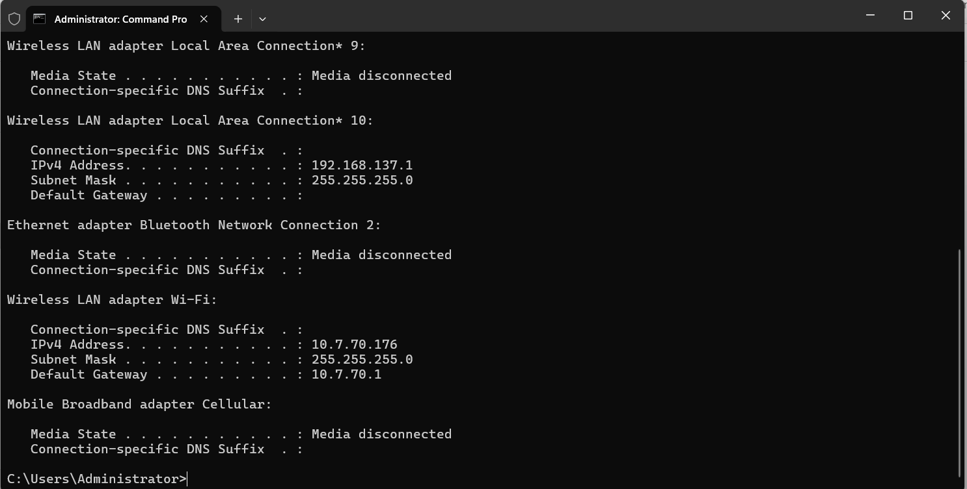

I run an IP config command on CMD to find networks on my local machine

Fig 2. Network scanning
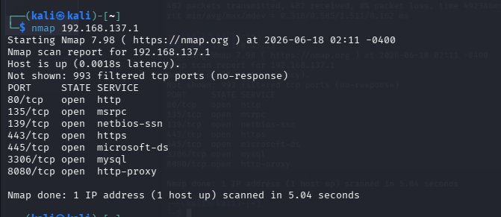

Fig 3. Service running discovery

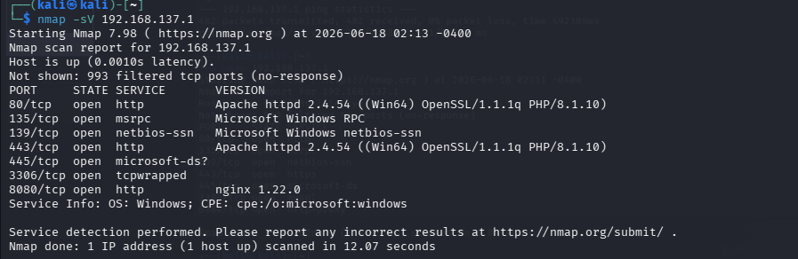

I scanned the ipv4 address of my local machine to detect services running on the network

Fig 4. Vulnerability assessment

Tools: Nikto

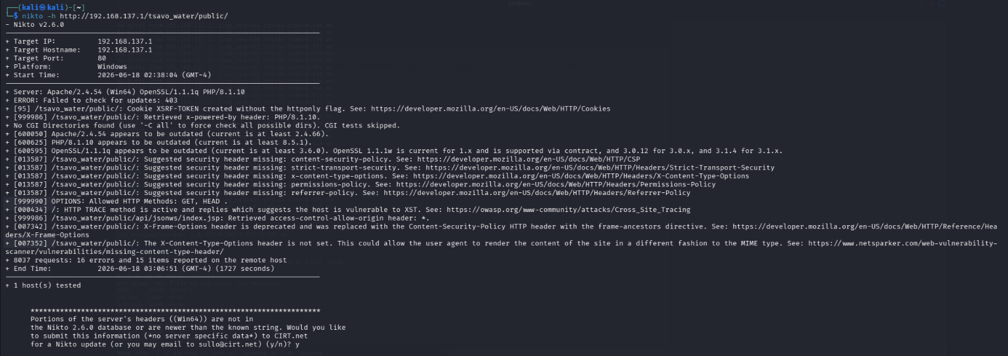

Key Findings from the Nikto Scan

1. Missing HTTP Only Flag on Cookie
Nikto found that the XSRF-TOKEN cookie was created without the HTTP Only flag.
Risk: Medium
Impact:
If a Cross-Site Scripting (XSS) vulnerability exists, malicious scripts may be able to access the cookie.
Recommendation:
Configure cookies with the HTTP Only attribute.

2. Technology Information Disclosure
The server reveals:
- Apache 2.4.54
- PHP 8.1.10
- OpenSSL 1.1.1q
through HTTP headers.
Risk: Low
Impact:
Attackers can identify software versions and search for known vulnerabilities.
Recommendation:
Remove or minimize server version disclosure headers.

3. Outdated Software Components
Nikto reported:
- Apache 2.4.54 outdated
- PHP 8.1.10 outdated
- OpenSSL 1.1.1q outdated
Risk: Medium
Impact:
Older versions may contain publicly known vulnerabilities.
Recommendation:
Update Apache, PHP, and OpenSSL to supported versions.

4. Missing Security Headers
The following headers are missing:
- Content-Security-Policy (CSP)
- Strict-Transport-Security (HSTS)
- X-Content-Type-Options
- Permissions-Policy
- Referrer-Policy
Risk: Medium
Impact:
Missing security headers increase exposure to attacks such as XSS, MIME sniffing, clickjacking, and information leakage.
Recommendation:
Implement appropriate HTTP security headers.

5. HTTP TRACE Method Enabled
Nikto reported:
HTTP TRACE method is active and replies which suggests the host is vulnerable to XST.
Risk: Medium
Impact:
TRACE can potentially be abused in Cross-Site Tracing attacks.
Recommendation:
Disable the TRACE method in Apache configuration.

6. Wildcard CORS Configuration
Nikto detected:
access-control-allow-origin: *
Risk: Medium
Impact:
Allows any domain to access resources, potentially increasing attack surface.
Recommendation:
Restrict CORS access to trusted domains only.

Risk Assessment Table
Vulnerability | Risk Level
Missing HTTP Only Cookie Flag | Medium
Information Disclosure | Low
Outdated Software Components | Medium
Missing Security Headers | Medium
HTTP TRACE Enabled | Medium
Wildcard CORS Configuration | Medium

Student Reflection (week 6)
During this practical, I performed a vulnerability assessment on the Tsavo Water Delivery System hosted locally on a Laragon server. Using Nmap and Nikto, I identified several security weaknesses, including outdated software versions, missing security headers, information disclosure, and insecure HTTP configurations. The exercise improved my understanding of web application security assessment and demonstrated how security misconfigurations can expose systems to potential attacks. This practical reinforced the importance of regular vulnerability scanning, secure server configuration, and implementing security best practices before deploying web applications to production environments.

